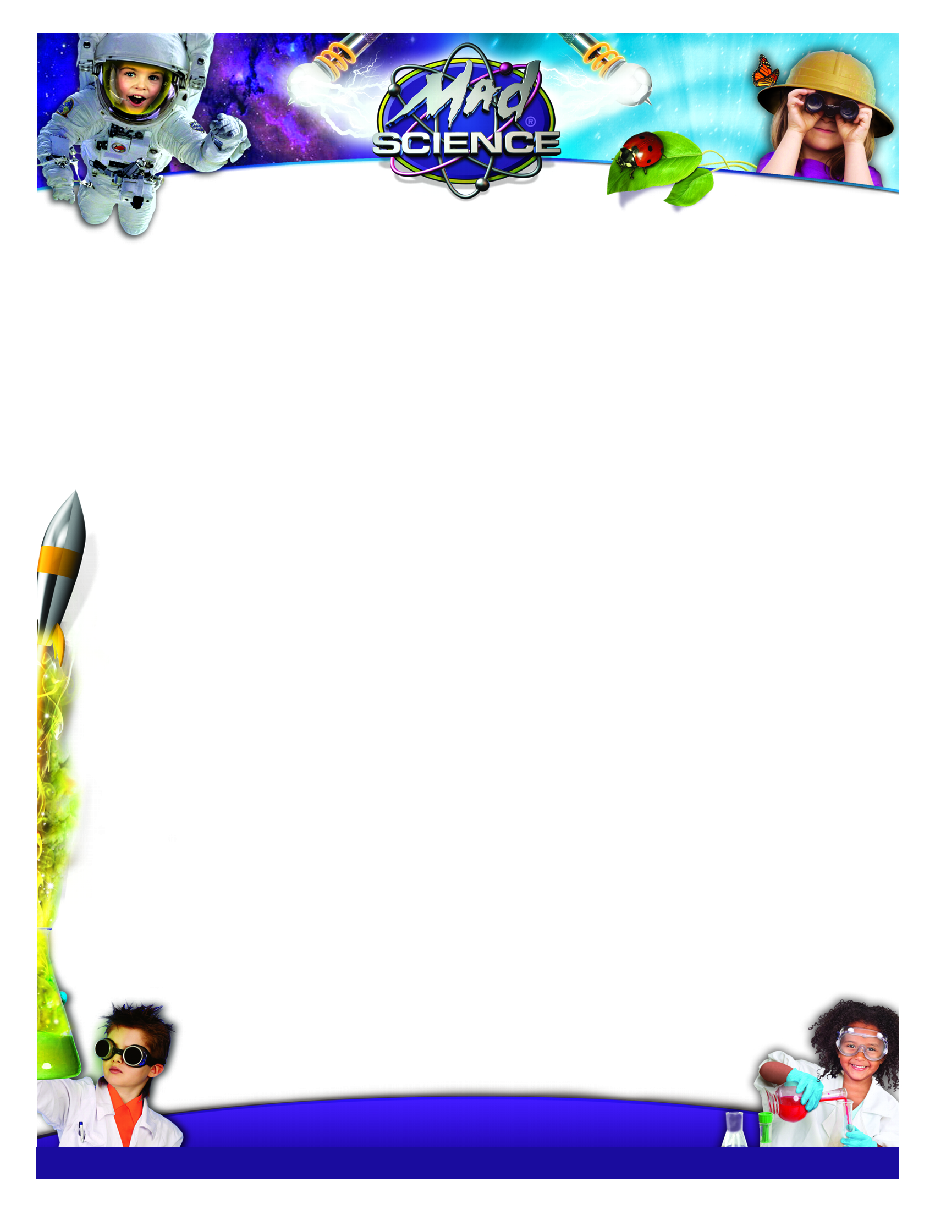

Have **FUN** after school with **Mad Science!**

***ENROLL YOUR CHILD* *ONLINE*** – and join us for our upcoming Mad Science adventure!

**At Hampton Park Elementary School   
Tuesdays 2:55pm to 3:55pm**

**April 19th to May 24th, 2016**

**6 week program**

**Open to Grades 1 to 5**

**All About Animals**

What is an animal? Children explore the animal kingdom and learn about the habitats, adaptations and life cycles of their favorite creatures. They experiment with animal calls and camouflage, and create their own **Animal Tracks** to take home.

**Life In The Sea**

The ocean holds many mysteries. Children learn about its diverse life forms—from plankton to whales! They discover underwater habitats, and learn how humans can help protect ocean life. The **Anaglyph Sea Puzzle** lets children dive in and take the ocean home.

**Energy Burst!**

Children explore the energy of motion. They pop, jump and flip with hopping, swimming and swinging toys. They check out the kinetic energy in rubber, band-wound gadgets and reach their potential with the **Catapult** Take-Home.

**Get Connected**

Let’s talk about telecommunications! Children chat over cables, link to a network and work with radio signals. Children wind through a cell tower relay and track cell phone users. They bring home the **Wired World**, an optical fiber telecommunications model.

**Mix It Up**

It’s time to shake up solutions and explore mixture chemistry. Children sort out mixtures, clear color from a watery solution and see how useful a suspension can be. The **Super Sorter** gives children the tools to sort mixtures at home.

**Moving Motion**

Children catapult into Newton's three laws of motion! They yank a cloth from under dishes, send crash test dummies flying and launch mini-rockets across the room. They see action–reaction forces at work with the twirling **Newton Spinner** Take-Home.

**Radical Robots**

Children become wrapped up in the world of robotics! Volunteers act out a robot, remote control device and an automaton. Children control an automaton through sound and make a soccer robot score a goal! They build their own **Robot Hand**—a human-like end effector.

**Super Power Sources**

How do we make electricity? Children explore renewable and non-renewable resources for power generation. They use mechanical force to turn on fans, and find out what makes a battery work. The **Crank’n Shine** gives children a chance to generate light!

***\*Please note only 6 of the above topics will be scheduled\****

**To Register Please Visit Our Website**

[**www.fraservalley.madscience.org**](http://www.madscience.org/fraservalley)

**If you are having difficulties registering, please contact us**

Phone 604-466-8888 Email info@madsciencefraservalley.ca

**Please do not give your payment to the school.**

**www.madscience.org**